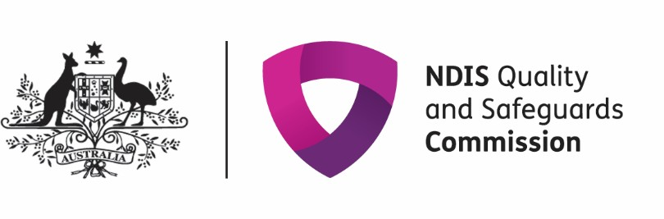

Dear NDIS Participant

This letter is about the new NDIS Quality and Safeguards Commission.

It is called the NDIS Commission for short.

The NDIS Commission will make sure support you get through NDIS is good and safe.


You have the right to be safe and have good quality services.

You have the right to make a complaint.

What we will do

Make sure services treat you well.

Tell workers they must follow the rules in the NDIS Code of Conduct. Make services report abuse, neglect and other bad things.
Give information and advice to make services better.

It is OK to complain

You can make a complaint about support you get through NDIS.



Talk to your service provider first

You can get help from family, a friend or an advocate.

If the service does not fix things or you are worried about talking to them, you can tell the NDIS Commission.

We will listen to you and we will try to make it better.

Making a complaint



You can make a complaint by phoning us. Phone: 1800 035544 (free call from landlines).

Or you can fill out the complaint form on our website www.ndiscommission.gov.au/participants/complaints

You can get more information from advocacy and information services. Here’s where to look up the advocacy organisations: https://disabilityadvocacyfinder.dss.gov.au/disability/ndap/

Speaking up can help make things better for you and others.

Yours sincerely
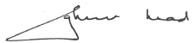

Graeme Head AO

NDIS Commissioner



