Step-by-step Guide on How to Create an ABN

Step 1: Go to the Australian Business Register Government Official website using the link below.

https://www.abr.gov.au/business-super-funds-charities/applying-abn

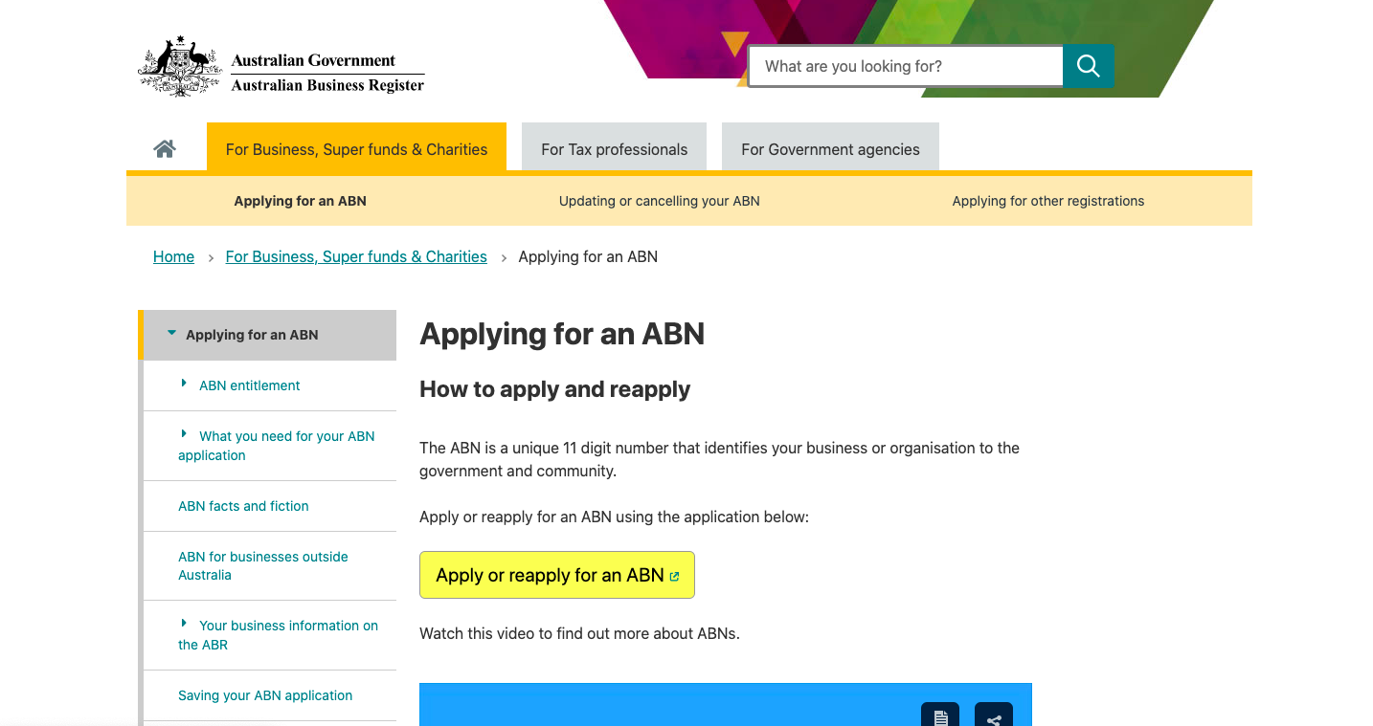
Step 2: Click on the ‘Apply or Reapply’ button.


Step 3: Read through the information and agree to provide correct information. Once completed, click next. As stated in the first sentence, tax agents are able to complete this process on your behalf.

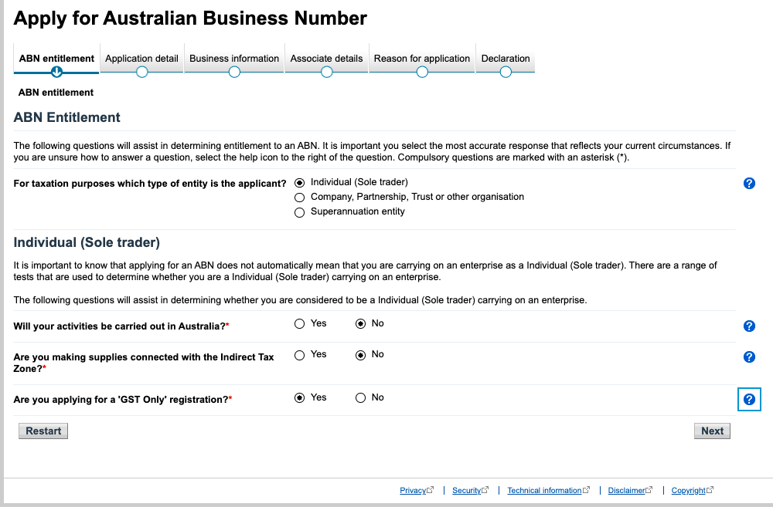
Step 4: If you are an individual sole trader, click this and follow the prompts. Once having complete click next. If you are unsure of which to select, click on the question mark which provides an explanation of the question.

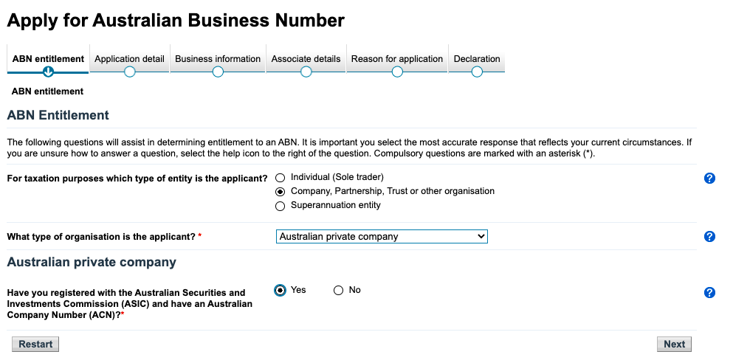
If you are applying for a Company, you must first see your accountant to apply for an ASIC registration to obtain an ACN.
Then you can follow the prompts and click next.
Note: The remainder of this document will be in regards to setting up an individual sole trader. All types of ABN’s follow the same process, however have different prompts suitable to the applicant (Company, Trust or Other, Superannuation Entity, or Sole Trader)

Step 5: Follow the prompts accordingly. Ensure you input ‘In the Form of a Business’, and ‘Yes’ for the question below.
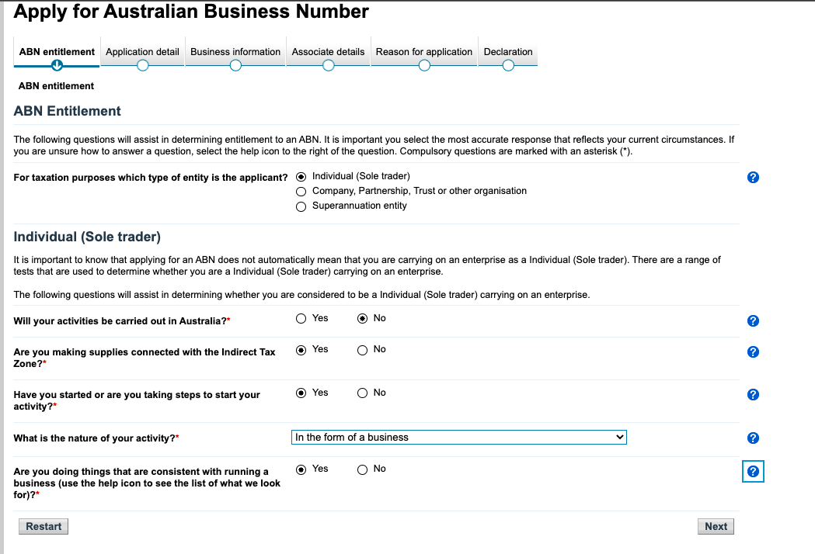

Step 6: Follow the remainder of the prompts and complete the declaration.

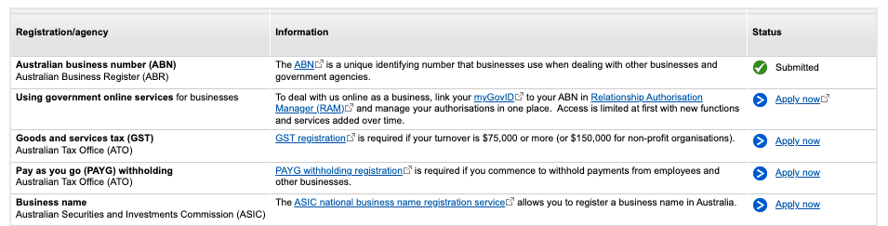
Step 7: Now, to register your trading name you can follow the link provided once you have set up your ABN.

